Appendix E. Adversarial security analysis
E.1 Motivation and scope
The main text describes the framework's security primitives in qualitative terms, and Appendix C derives an economic cost-of-attack inequality for the oracle layer. To complement these treatments with systematic adversarial evidence, this appendix provides a pre-deployment, design-time security evaluation along three coordinated axes: a formal threat model that enumerates attack vectors against each architectural component, closed-form economic bounds that extend the Appendix C cost-of-attack formula into bribery-resistance, collusion-resistance, and stake-adequacy statements, and an empirical adversarial simulation that quantifies the framework's robustness under adaptive attacker and colluding oracle scenarios.
Full production-grade penetration testing requires deployment at commercial scale and external third-party engagement, both of which are reserved for the pilot phase outlined in the Future Work discussion. The analyses reported below are not a substitute for that empirical security validation; they are the design-time foundation against which the pilot's red-team exercises and audit findings will be benchmarked.
E.2 Threat model
The threat enumeration combines the STRIDE classification used in distributed systems security with the Decentralized Application Security Project (DASP) top ten list for smart contract specific risks. Table E1 maps each STRIDE category to the framework component most exposed to that threat, identifies a concrete attack vector, and documents the design control that mitigates the threat. Table E2 maps the DASP top ten smart contract risks to the framework's implementation decisions.
Table E1. STRIDE-based threat enumeration and mitigation
STRIDE category | Attack vector | Affected component | Design control
Spoofing | Forged oracle attestation, sensor or node impersonation | Oracle layer | k-of-n threshold signing with staked identities; cryptographic node enrollment
Tampering | Post-hoc modification of quality records or audit log | Smart contract, off-chain storage | Immutable on-chain hash anchor over content-addressed off-chain blob; Merkle proof verification
Repudiation | Producer or inspector denies having submitted an attestation | Smart contract | Non-repudiable signed transactions with persistent on-chain provenance
Information disclosure | Leakage of confidential mix designs or commercial terms | Off-chain storage | Selective disclosure with on-chain hash commitments; no plaintext business data on-chain
Denial of service | Resource exhaustion against oracle network or chain throughput | Oracle layer, consortium chain | Multi-oracle redundancy; gas-bound execution paths; rate limiting via permissioned access
Elevation of privilege | Unauthorized contract upgrade or admin role takeover | Smart contract | Multi-signature governance for upgrades; time-locked deployment; role-based access modifiers
Table E2. DASP top ten smart contract risk coverage
DASP top ten risk | Coverage in the framework
Reentrancy | Checks-effects-interactions pattern; no external calls before state updates
Access control | Role-based modifiers; multi-signature for privileged operations
Arithmetic over- and underflow | Solidity 0.8+ checked arithmetic; explicit bounds for cost and stake variables
Unchecked low-level calls | Return values verified for all call, delegatecall, send, transfer operations
Denial of service | Pull payment pattern; gas-bound loops; per-call cost ceilings
Bad randomness | Not used; quality verification is deterministic over signed measurements
Front-running | Commit-reveal scheme for oracle attestations; signature-bound submission ordering
Time manipulation | Tolerance bands on block timestamps; verification windows expressed in block counts
Short address attack | Input length validation in all externally exposed functions
Unknown unknowns | Third-party audit before pilot; staged deployment; bug bounty post-pilot

E.3 Economic security bounds
Building on the cost-of-attack formula in Appendix C, three closed-form bounds capture the framework's adversarial economic security. Let m denote the corruption threshold of the m-of-n oracle quorum, B the bribe per colluding node, S the slashable stake per node, and G the attacker gain from a successful corrupted attestation. The cost-of-attack inequality requires $CoA = m\left(B + S\right)≥ G$.
Bribery resistance. Under the credible assumption that an honest minority detects and reports collusion with non-trivial probability, the minimum stake adequate to deter bribery satisfies $S^{*}>=\frac{G}{m}-B$, where the term G/m measures the corruption rent per colluding node and B compensates the participation cost. The framework's design therefore makes S* the operational tuning knob for security against bribery.
Collusion resistance. For an adversary attempting to corrupt the m-of-n quorum through independent compromise of individual nodes, the probability of quorum corruption follows the binomial tail $Pr\left[corruption\right]=\sum_{k=m}^{n}{ C\left(n, k\right)p_{c}^{k} {\left(1 - p_{c}\right)}^{n - k}}$, where $p_{c}$ is the per-node compromise probability. The framework provides resistance both by increasing the quorum threshold m and by maintaining node independence through diverse stake holders, geographical distribution, and key isolation.
Stake adequacy under consequence scaling. The attacker gain G scales with the consequence severity of the underlying batch lot, since corrupting an attestation enables substandard delivery whose downstream cost is a function of the failure consequence multiplier defined in Appendix D. Writing $G(mult) = N(g0 + p_{fail}× mult× c0)$, where N is the lot size, g0 the per-batch cost-saving gain, $p_{fail}$ the latent failure probability, and c0 the direct-cost baseline, the stake-adequacy condition becomes $S^{*}\left(mult\right)≥G(mult)/m-B$. The required stake therefore grows linearly with the consequence multiplier, providing a transparent rule for parameterizing security to project risk.
E.4 Adversarial simulation results
Fig. E1 reports three adversarial experiments executed on the same Monte Carlo harness used in Section 6.2, with 20,000 batches per scenario and a fixed random seed for reproducibility. Panel (a) tracks the adaptive attacker's net payoff per batch as a function of the oracle true positive rate beta under a conservative limited-liability regime in which the producer treats only contemporaneous detection at pre-delivery and at the 28-day stage as binding penalty events. Panel (b) reports the probability that an m-of-n threshold-signing quorum is corrupted under independent compromise of individual nodes. Panel (c) reports the minimum slashable stake per node required to keep the cost of attack above the attacker gain across consequence multipliers matching the Appendix D scaling.
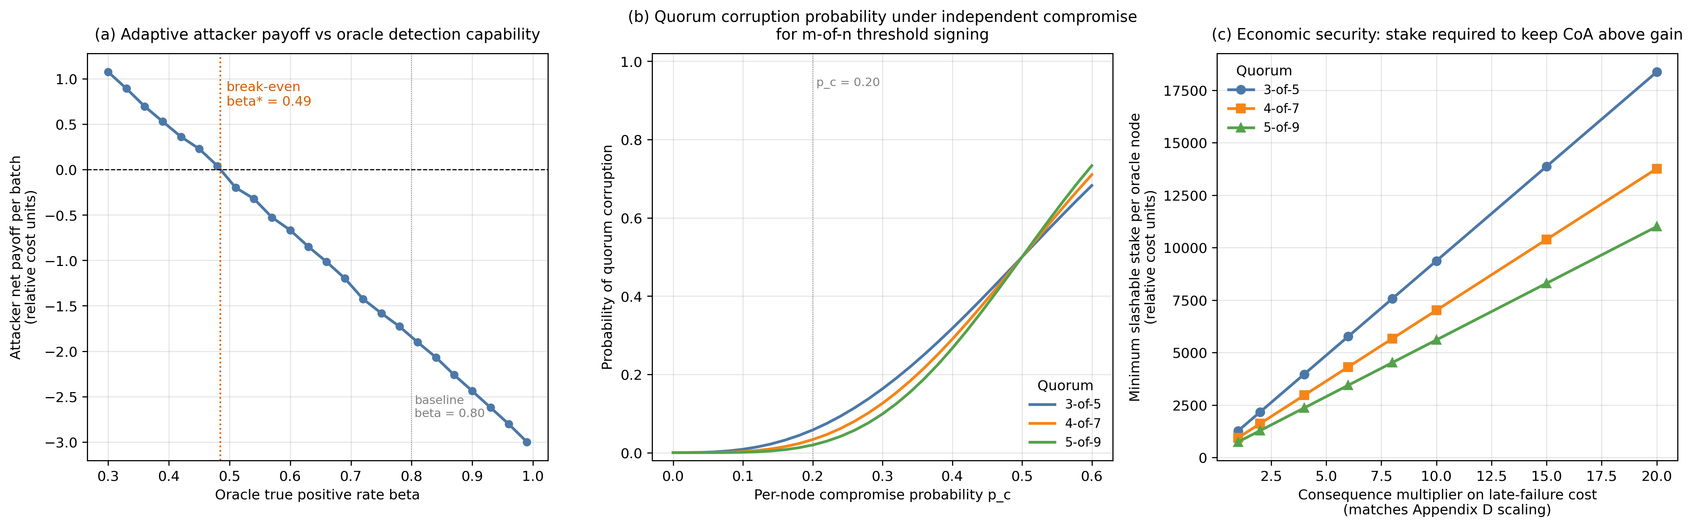
Fig. E1. Adversarial security analysis. Panel (a) adaptive attacker break-even oracle TPR. Panel (b) quorum corruption probability. Panel (c) stake adequacy under consequence-scaled attacker gain.
Three quantitative findings emerge. First, the break-even oracle true positive rate is beta* = 0.485, well below the baseline beta = 0.80 calibrated in Section 6.2. At the baseline operating point the attacker net payoff is approximately -1.83 cost units per batch, providing a robustness margin of roughly 65 percent above the deterrence threshold. Even under sustained oracle performance degradation, fraud remains unprofitable across most of the credible range.
Second, the binomial quorum analysis shows that for a per-node compromise probability of p_c = 0.20, the probability of quorum corruption is 5.79 percent for a 3-of-5 quorum, 3.33 percent for a 4-of-7 quorum, and 1.96 percent for a 5-of-9 quorum. Larger quorums substantially reduce corruption probability, with the gain increasing rapidly above the m/n = 0.6 threshold consistent with classical Byzantine fault tolerance bounds.
Third, the stake-adequacy analysis quantifies the protective deposit needed to neutralize attacker incentive. For the representative scenario of N = 50 batches per attestation decision and a bribe of B = 50 cost units per node, the minimum stake per node at a consequence multiplier of one is approximately 1,267 cost units for a 3-of-5 quorum, rising to 9,367 cost units at a multiplier of ten and 18,817 at a multiplier of twenty. A 5-of-9 quorum reduces these stake requirements by approximately 40 percent for the same consequence multiplier, illustrating the economic value of quorum redundancy.
E.5 Residual risks and pilot-phase audit roadmap
Three categories of residual risk are not addressable through design-time analysis alone. First, off-chain sensor integrity at the data-acquisition layer (firmware tampering, sensor substitution, calibration manipulation) lies outside the trust boundary established by the on-chain controls. Second, key management compromise of staked oracle node identities, including operational security failures by node operators, requires hardware-backed key storage and operational discipline that can only be validated under field conditions. Third, supply-chain attacks against the oracle software stack and the consortium chain client require continuous monitoring through reproducible builds, signed release pipelines, and external audit.
The framework's security validation plan therefore commits to three pilot-phase activities that complement the design-time analyses reported above. A third-party smart contract audit will be conducted before the pilot deployment, with audit scope defined to cover Tables E1 and E2 and the economic bounds in Section E.3. A red-team exercise will be commissioned during the pilot, with red-team objectives explicitly aligned to the adversarial scenarios simulated in Section E.4. A continuing bug bounty program will be operated post-pilot, with bounty severity tiers calibrated against the attacker gain function G(mult) defined in Section E.3 so that monetary rewards scale with the security impact of the disclosed vulnerability. Together with the analytical and simulation evidence in this appendix, this validation plan provides a credible bridge from pre-deployment design assurance to production-grade security guarantees.

